Ormiston Academies Trust
Managing Teacher Capability policy

Policy version control

Policy type | OAT Mandatory  The Trust will regularly monitor and review this policy to ensure that it is appropriate, effective, and compliant with both employment legislation and the Equality Act 2010
Author  In consultation with | Melanie Wheeler  ASCL, GMB, NAHT, NASUWT, NEU, Unison & Unite
Approved by | Carmel Brown, National Director for HR & Operations, May 2021
Status | Consulted
Release date | May 2021
Next release date | May 2024
Description of changes | - Five working days’ notice to be provided for meetings.  - Five working days to appeal any formal notices.  - Stages of capability re named to formal stage one, formal stage two, final formal and decision hearing.

Contents
1. Introduction 4
2. Purpose 4
3. Considerations 4
4. Capability procedure 5
5. Capability overview 5
6. Notification of formal capability meeting 5
7. Formal capability meeting 5
8. Monitoring and review period following a formal capability meeting 6
9. Formal review meeting 7
10. Final monitoring and review period 7
11. Decision meeting 8
12. Appeal 8
Appendix 1 10
Capability flowchart 10
Appendix 2 11
Guidance Note: Conducting a formal capability meeting 11
Appendix 3 12
Outcome of formal/final formal capability meeting letter 12
Appendix 4 14
Guidance note: conducting a final formal meeting 14
Appendix 5 15
Performance improvement and support plan 15
Appendix 6 16
Guidance note: Conducting a formal capability review 16
Appendix 7 17
Letter following formal/final formal review meeting 17
Appendix 8 19
Meeting to consider dismissal on the grounds of capability 19
Appendix 9 20
Guidance note: meeting to hear an appeal against a formal (or final formal) warning, dismissal on the grounds of capability 20

Glossary:
This procedure applies to academy-based teachers. Unless otherwise indicated the following terms are interchangeable:
- Teacher – applies to qualified teachers
- Principal – applies to principal or line manager
- Governors – applies to members of the academy’s governing body
- Appeal governors – applies to members of the academy’s governing body
- Introduction
  - Ormiston Academies Trust have overall responsibility for the effective operation of this policy and for ensuring compliance with the relevant statutory framework. The Principal has delegated day-to-day responsibility for operating the policy.
- Purpose
  - The purpose of this procedure is to detail arrangements which will apply when teachers fall below the levels of competence that are expected, and to provide a framework that supports them in such cases to improve performance. There is a commitment by the academy to treat individuals with fairness throughout the process.
    - This policy is not intended to address issues of willful under-performance; these cases should be addressed using the disciplinary procedure; nor should it be applied to cases of unsatisfactory performance due to absence which should be dealt with using the supporting staff attendance policy.
    - The formal capability procedure applies to teachers (including the Principal) where there are serious substantiated concerns about performance that the appraisal process has been unable to address through day-to-day discussions about performance/issues with line managers and informal support.
  - The procedures set out in this policy seek to ensure that this is achieved in a fair equitable and transparent way.
  - The Governing Body/Trust recognises its responsibilities under relevant legislation including:
- the Equality Act 2010
- the Employment Relations Act 1999
- the Part-time workers (Prevention of Less Favourable Treatment) Regulations 2000
- the Fixed-Term Employees (Prevention of Less Favourable Treatment) Regulations 2002
- the Employment Rights Act 1996
- the Employment Act 2002
- The Employment Act 2002 (Dispute Resolution) Regulations
and will ensure that all pay related decisions are taken equitably and fairly, in compliance with statutory requirements.
- Considerations
  - If sickness absence appears to have been triggered by the commencement of formal capability procedures, the case will be dealt with in accordance with the supporting staff attendance policy and the employee may be referred to the occupational health service. Having sought advice from occupational health, formal procedures may continue during a period of sickness absence.
  - Due to the formal nature of capability meetings, all meetings held under this policy will be arranged with a minimum of 5 working days’ notice and with the right for the employee to be accompanied by either a work colleague or trade union representative. A record will be kept of all formal meetings.
- Capability procedure
  - The purpose of the capability procedure is to improve performance through support and applies to teachers, excluding NQTs who have their performance managed through the induction process, when there are serious concerns with regard to performance against the relevant standards which have failed to be addressed through the appraisal process. If the application of this procedure fails to secure sufficient progress, it may lead to dismissal.
- Capability overview
  - It is expected that the capability process will take no more than one term (i.e. thirteen weeks) however each review period should be no less than four weeks to allow improvements to be made. An overview of the process and timescales can be found in appendix 1.
  - In cases other than where there are very serious concerns substantiated by evidence about performance, it is expected that support will have been provided under the appraisal process prior to moving to formal capability procedures.
- Notification of formal capability meeting
  - As with all formal meetings held under this procedure, at least five working days’ notice will be given in writing of the formal capability meeting. This will include the sharing of all relevant information and evidence regarding the concerns about performance, and possible consequences, to enable the teacher to prepare.
  - Leaders and managers may seek advice from OAT HR when dealing with an employee under formal capability.
  - At all meetings, the teacher may be accompanied by either a work colleague or a trade union representative and should be encouraged to seek the appropriate support throughout the process.
- Formal capability meeting
  - This meeting will be conducted by the Principal or formally nominated member of the senior leadership Team at the direction of the Principal (or the Regional Director in the case of principal capability). The formal capability meeting will continue following the format at appendix 2 and seek to agree a Performance Improvement Plan (template found at appendix 5). If agreement on this is not possible the person conducting the meeting will determine the content of the plan. In these circumstances, the appraisal process will stop. A note taker should be present.

  - The first stage of the meeting allows the teacher to respond to concerns about their performance and to make any relevant representations which may provide new information or a different context to the information/evidence already collected and the concerns about performance.
  - Once all representations have been heard, either party may request an adjournment. During the adjournment, the person conducting the meeting will consider the information presented and make a decision on how the case will progress.
  - Following this, the person conducting the meeting has four options:
    - To conclude that there are insufficient grounds for pursuing the capability issue and that it would be more appropriate to continue to address the remaining concerns through the appraisal process. In such cases, the capability procedure will come to an end. A further meeting may then be arranged under the appraisal process to reassess objectives and timescales.
    - To choose to suspend the meeting to gather more information in light of the employee’s response or to give more time to consider the information. In this case a date for the reconvened meeting should be agreed.
    - To decide that there is a need to instigate the formal capability process. In this case a formal written warning should be issued to the employee (appendix 3).
    - To decide that there is a need to instigate the formal capability process and issues raised are so serious that a final formal written warning should be issued. The advice of HR may be sought prior to this action. Where a final formal written warning is to be issued, the meeting format at appendix 4 should then be followed and should seek to agree an appropriate Performance Improvement Plan, (template found in appendix 5). Where agreement is not possible, the person conducting the meeting will determine the content of the plan. In these circumstances, the appraisal process will stop.
  - The outcome of this meeting will be confirmed in writing within five working days along with details of the right to appeal the decision. This letter will also inform the teacher of the matters covered during the meeting, and (where appropriate) a copy of the Performance Improvement Plan, details of the timescales and the review stage. A template letter can be found in appendix 3.
  - Appeals should be made in writing to the chair of governors (for Principals to the National Director of Education) within five working days of receipt of the letter confirming the warning being issued. Where the teacher submits an appeal, the capability process will continue whilst awaiting the outcome.
  - A review period will follow the formal capability meeting, in line with the timescales outlined and will reflect the complexity and number of objectives set in the Performance Improvement Plan. Formal monitoring, evaluation, guidance and support will continue during this period.
- Formal reviews
  - On conclusion of the review period the Teacher will be invited to a formal meeting, to review their progress. Employees should be given a minimum of five working days’ notice to attend.
  - Appendix 6 details the points to be addressed during this meeting.
  - After reviewing the progress made against the previously agreed targets, a decision should be made as to whether sufficient improvement has been made. There are two possible outcomes:
    - If the reviewer is satisfied that the teacher has met the targets or made sufficient improvements/progress set out in the Performance Improvement Plan, the capability procedure will cease and the appraisal process will re-start. This decision should be confirmed in writing within five working days (appendix 7).
    - If the targets in the Performance Improvement Plan have not been met during the monitoring and review period, the teacher will receive a final formal written warning, within five working days.
    - The teacher is given the right of appeal against the formal written warning; this should be made in writing to the chair of governors (or National Director of Education for Principals) within five working days of receipt of the letter confirming the warning being issued.

  - Where a final formal written warning is issued, the teacher will receive written information, within five working days, about the further monitoring and review period and be informed in writing that failure to meet the Performance Improvement Plan, within the set timescale, may result in dismissal.
  - This monitoring period should be determined with consideration to the targets set in the Performance Improvement Plan. This should be a minimum of four weeks to allow sufficient time for improvements to be made.
  - The teacher is given the right of appeal against the final formal written warning; this should be made in writing to the chair of governors (or National Director of Education for Principals) within five working days of receipt of the letter confirming the warning being issued.
- Final review
  - Following the final monitoring and review period, a final formal meeting will be held. Employees should be given five working days’ notice of this meeting along with the right to be accompanied at the meeting by a work colleague or trade union representative.
  - This meeting will follow the format for the formal review meeting as described in appendix 6.
  - After reviewing the progress made against the previously agreed targets, a decision should be made as to whether the Performance Improvement Plan targets have been made or sufficient improvements/progress have been made. There are two possible outcomes:
    - If performance improvement plan targets have been achieved during the further monitoring and review period, the capability procedure will end and the appraisal process will re-start.
    - If performance improvement plan targets have not been met consideration will be given as to whether the teacher should be referred to Governors for consideration of dismissal on the grounds of capability.
  - The outcome of this meeting will be confirmed in writing within five working days.
- Decision meeting
  - The teacher will be given a minimum of ten working days’ notice of the Governors decision meeting and will be given copies of any documentary evidence that will be referred to during the meeting. Employees should be informed that any documentation they wish to refer to during the meeting should be sent to the chair of the decision meeting panel no later than two working days before the meeting.
  - The decision meeting panel should consist of three governors; however, one panel member can be the Principal as long they have had no previous involvement in the capability process. The meeting should follow the format in appendix 8.
  - There are three potential outcomes for the decision meeting:
    - That the panel determine that performance of the teacher, in relation to the targets stated in the performance improvement plan, have been met and therefore the teacher should remain in post and resume their role in the normal appraisal process.
    - That the panel determine that performance of the teacher, in relation to the targets stated in the Performance Improvement Plan have not been met due to exceptional circumstances and as such progress toward meeting those targets will be reviewed again after an agreed period.
    - That the panel determines that the teacher has failed to make sufficient improvement meet the national standards expected in relation to the targets set in the Performance Improvement Plan and that the teacher should be dismissed, as the teacher has failed to demonstrate their capability to attain that standard in this academy.
  - If a decision to dismiss has been taken, the teacher will receive appropriate notice.
- Appeal
  - A teacher has the right of appeal against their dismissal. Any appeal should be in writing to the clerk of governors within ten working days of receiving the letter confirming the decision, stating the grounds for appeal.
  - Appeals will be heard without unreasonable delay and will be heard by three governors who have not previously been involved in the case. The meeting will take the format as describe in appendix 9.
  - The teacher will be informed in writing of the outcome of the appeal hearing as soon as possible.
  - There is no further recourse for appeal under this procedure

Appendix 1

Capability flowchart
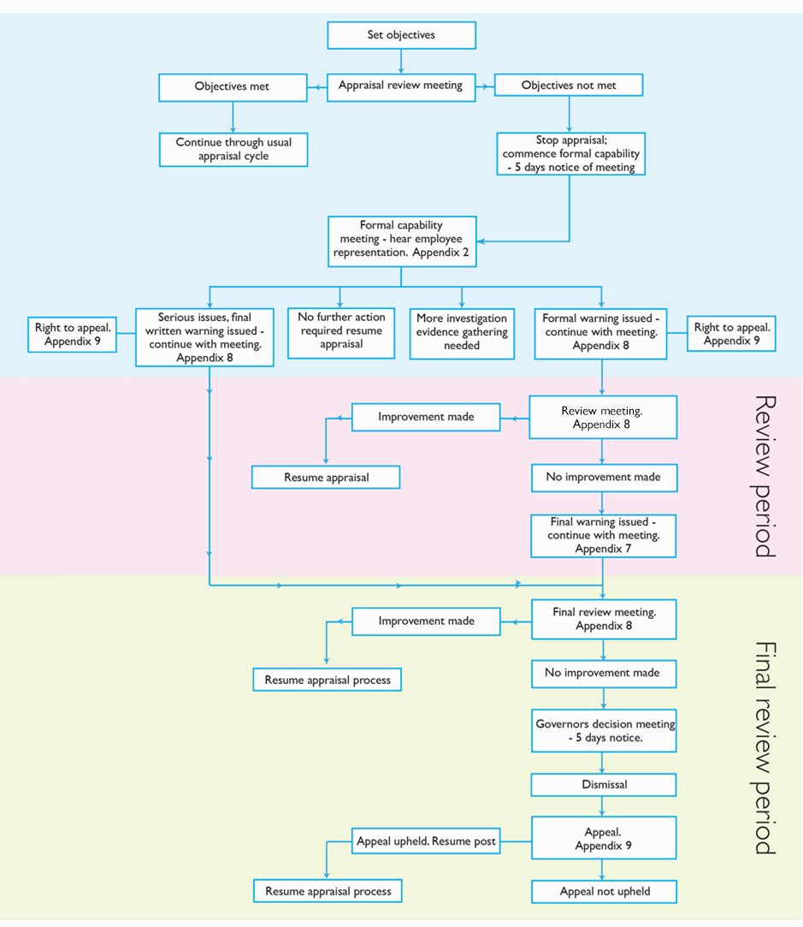

Appendix 2

Guidance Note: Conducting a formal capability meeting.
- Advise the teacher of nature of the meeting and that they have the right to be represented.
- Allow 5 working days’ notice to attend.
- Ensure the teacher is provided with a copy of this policy, if not already provided.
- Give clear feedback to the teacher about the nature and seriousness of the concerns
- Ensure the teacher has the opportunity to respond, provide reasons/explanation for the performance shortfall.
- Ask the teacher if there are any underlying issues that may impact on performance, e.g. health, issues outside work etc. If health is a concern advise the teacher that you will arrange an appointment with Occupational Health.
- On hearing all representations either party may request an adjournment to consider information presented (refer to 13.4, Part B). Following this there are four options:
  - To conclude there are insufficient grounds to pursue capability and therefore cease capability and resume appraisal process.
  - Suspend the meeting to gather more information
  - To instigate formal capability and issue a formal written warning – follow this format of remainder of meeting.
  - To instigate formal capability however due to seriousness of concerns issue a final formal written warning. Refer to Appendix 9 for format of remainder of meeting.
If continuing formal capability and issuing a formal written warning:
- Advise the teacher that they are being issued with a formal warning under this policy, and that this will be confirmed in writing within five working days.
- Advise the teacher member that they have the right of appeal against the formal warning, and that details of the appeal process will be confirmed to them in writing.
- Agree any support (e.g. coaching, mentoring, structured observations), that will be provided to help address those specific concerns, performance measures and timescales. Agree interim review meetings if appropriate.
- Advise the teacher that if performance does not meet the required level within the review period they may be issued with a final written warning, and that ultimately the capability process can lead to dismissal.

Appendix 3

Outcome of formal capability meeting, letter template
Your reference
Our reference, Letter – outcome of formal meeting
Date

[Name]
[Address]

Dear XXXX,

Outcome of formal/final formal capability Meeting

Thank you for attending the meeting on XXX at which you chose/chose not to be accompanied by your Union representative XXXX to discuss your performance. This meeting was held in accordance with the capability procedure for teachers.
At the meeting, I explained to you that the purpose of the meeting was to discuss concerns regarding your performance and to hear your responses in relation to these.
During the meeting, I explained that (insert details of concerns and evidence). You were given the opportunity to respond to these, you explained that (insert details of response).
Having considered the points raised I concluded that: (delete as appropriate)
a) That whilst there are issues with aspects of your performance, it would be more appropriate to address these concerns through the appraisal process. As such the capability process will now cease and you will resume the appraisal process. A further meeting will be arranged to reassess your objectives.
b) The meeting should be suspended to allow time to collect/consider further information. (insert details of reconvened meeting)
c) That significant performance concerns exist and as such it is appropriate to continue with the capability process as such you were issued with a formal warning that your performance should improve.
You have the right to appeal this decision; appeals should be made in writing to the chair of governors within ten days of receipt of this letter.
d) That performance concerns exist which are serious in their nature, as such it is appropriate to continue with the capability process as such you were issued with a final formal warning that your performance should improve.
You have the right to appeal this decision, appeals should be made in writing to the chair of governors within five days of receipt of this letter.
In light of this decision I then explained you will be subject to a monitoring period of XX weeks (minimum 4) and discussed the Performance Improvement plan with you to highlight your targets, measures and agreed support. (insert summary of agreed plan). A copy of the revised plan is enclosed.
Following this period, you will be reviewed again. Failure to make sufficient improvements during this review period will result in you being issued with a final formal waning to improve performance/ your case being referred to governors for a decision to be made on your ongoing employment.
I am sorry that this has become necessary however I would encourage you to contact me should you need any clarification on the issues raised or require additional support and hope that you will be able to make and sustain the necessary improvements.
Yours sincerely

Name
Designation
E-mail address
Telephone number

Appendix 4

Guidance note: conducting a final formal meeting – (see 7.4.4

Advise the member of staff of nature of the meeting and that they have the right to be represented.
- Provide five working days’ notice of the meeting.
- Ensure the member of staff is provided with a copy of policy, if not already provided.
- Clearly highlight the specific areas of performance that are causing concern and discuss the evidence of this.
- Ensure the member of staff has the opportunity to respond, provide reasons/explanations for the performance shortfall.
- Ask the staff member if there are any underlying issues that may impact on performance, e.g. health, issues outside work etc. If health is a concern advise the member of staff that you will arrange an appointment with Occupational Health
- Advise the staff member that they are being issued with a final formal warning under this policy, and that this will be confirmed in writing.
- Advise the staff member that they have the right of appeal against the final formal warning, and that details of the appeal process will be confirmed to them in writing.
- Advise the staff member that Performance Management under the PM policy is suspended pending the outcome of the informal capability procedures.
- Agree any support (e.g. coaching, mentoring, structured observations), that will be provided to help address those specific concerns, performance measures and timescales. Agree interim review meetings if appropriate
- Discuss the generic stress risk assessment with the staff member (see Appendix 2). Ask the employee if there are any additional actions that can be taken to support them and to help minimise stress. Record these in the additional information column.
- Agree a date for review against the targets, minimum of four weeks.
- Advise the staff member that if performance does not meet the required level within the review period then the matter may be referred to the governors with a recommendation for their dismissal.
- As teachers, advise them that if they are dismissed by the governors for capability, the matter will be referred to the teachers Standards Agency for them to consider whether the staff member should continue to practice as a Teacher.

Appendix 5

Template Sample, Performance improvement and support plan
To be used in conjunction with the capability procedure.
Target | Measured by | Support e.g. training, supervision, mentoring etc. | Date to be achieved by/review date

Once completed, a copy of the agreed plan should be sent to the employee with a copy to their representative.

Appendix 6

Guidance note: Conducting a formal capability review.
- Advise the staff member that this meeting is a formal review under the capability policy, and that they have the right to be represented.
- The principal (or formally nominated member of the senior leadership team) should present evidence regarding the staff member’s performance against the targets specified in the formal capability meeting.
- The staff member should be asked for their opinion regarding their performance against the targets.
- The staff member should be asked if there are any underlying reasons, health, etc., that should be taken into consideration.
- The principal should adjourn the meeting at this point to consider the evidence.
- If the staff member has achieved the targets, and the principal believes this can be sustained, they should be advised that the capability process is finishing, and they should be encouraged to maintain this level of performance. A discussion may take place regarding phasing out of any support.
- A discussion should take place around the re-commencing of normal appraisal process, and an addendum may need to be made to the Performance Management statement detailing any revision of targets etc.
- If the staff member has not achieved the targets, they should be advised that they are being issued with a final formal warning which will be confirmed in writing. Advise that they have the right to appeal the warning and that details of this will be confirmed in writing.
- Revisit performance development plan revise as appropriate and set new targets, measures and timescales as necessary.
- Explain that failure to make improvement after this review period will result in case being referred to governors for a Decision Meeting.

Appendix 7

Letter following formal/final formal review meeting
Your reference
Our reference xxxxx Letter – improvement made following capability.
Date

[Name]
[Address]

Dear XXXX,
Outcome of meeting– (formal/final formal) capability review
Thank you for attending the meeting on XXX at which you chose/chose not to be accompanied by your Union representative XXXX to discuss your performance. This meeting was held in accordance with the capability procedure for teachers.
At the meeting, I explained to you that the purpose of the meeting was to review the progress since our initial meeting/first formal review meeting that took place on XXXX. At this meeting, an action plan of specific performance targets was provided to you in order to help you address those issues and enable you to perform to the required standards.
We reviewed those targets as set out within the agreed action plan which are summarised below;
i. Insert summary of performance improvement support plan
You responded to the review stating xxxxxxx (insert summary of response)
Following consideration of the points raised I concluded that (delete as appropriate)
a) That you have made sufficient improvement over the review period, as such the capability process will now end and you will resume the usual appraisal process. As discussed in the meeting any remaining issues (insert detail of issues) will now be addressed using additional objectives and support in the appraisal process.
It is important however that these improvements are sustained, failure to sustain the required level of performance may result in you re-entering the capability process.
b) That you have made insufficient/no progress against the agreed targets, as such you are issued with a final formal warning.
You have the right to appeal this decision, appeals should be made in writing to the chair of governors within ten days of receiving this letter, stating your reasons for appeal.
In light of this decision, I then explained you will be subject to a further monitoring period of XX weeks (minimum 4). During this period, you will receive the support as agreed in your revised Performance Improvement Plan and will be assessed against the agreed targets. A copy of the revised plan is enclosed.
Following this period, you will be reviewed again. Failure to make sufficient improvements during this review period will result in your case being referred to governors for a decision to be made on your ongoing employment.
c) That you have made little/no improvement against agreed targets. As you have previously received a final formal warning regarding your capability your case will now be referred to governors for a decision to be made on your ongoing employment. You will receive a letter inviting you to this meeting in due course.
(Delete as appropriate) I am pleased that you have been able to make these improvements and hope that you will be able to sustain these and develop further. Should you require any ongoing support please do not hesitate to contact me.
I am sorry that this has become necessary however I would encourage you to contact me should you need any clarification on the issues raised or require additional support and hope that you will be able to make and sustain the necessary improvements.
Yours sincerely

Name
Designation
E-mail address
Telephone number

Appendix 8

Meeting to consider dismissal on the grounds of capability
- Introduction by chairperson; explanation of procedure.
- The appraiser should present the case for dismissal.
- Employee (or representative) may ask questions of appraiser.
- The chairperson/committee members and HR representative may ask questions of the appraiser.
- Appraiser to call witness(es) if applicable.
- Employee (or representative) may ask questions of appraiser’s witness(es).
- The chairperson/committee members and HR representative may ask questions of the appraiser’s witness(es).
- Employee (or representative) should present his/her case.
- The appraiser may ask questions of the employee (or representative).
- The chairperson/committee members and director’s representative may ask questions of the employee (or representative) and ask further questions of the appraiser’s regarding the case made on behalf of the employee.
- Employee (or representative) to call witness(es) if applicable.
- The appraiser may ask questions of the employee’s witness(es).
- The chairperson/committee members and HR representative may ask questions of the employee’s witness(es).
- Appraiser to sum up case.
- The employee (or representative) to sum up case.
- Parties to retire; the HR representative may remain with the chairperson/committee to offer advice. The chairperson/committee to consider the cases presented. The chairperson will notify the parties of their decision. This may be conveyed at the conclusion of the hearing but will in any case be confirmed in writing, with information on any further appeal rights where appropriate.
This procedure may be varied by agreement with all the parties.

Appendix 9

Guidance note: meeting to hear an appeal against a formal (or final formal) warning, dismissal on the grounds of capability
- Introductions by chair: explanation of procedure.
- Appellant or representative to state his/her grounds for appeal.
- First committee representative/principal may ask questions of appellant.
- Appeals committee members/HR representative may ask questions of the appellant.
- Appellant to call witness(es) (if applicable)
- First committee representative/principal may ask questions of appellant’s witness(es)
- Appeals committee members/HR representative may ask questions of the appellant’s witness(es).
- First committee representative/principal to state the academy’s case.
- Appellant (or representative) may ask questions of first committee representative/principal.
- Appeals committee members/HR representative may ask questions of first committee representative/principal.
- First committee representative/principal to call witness(es) (if applicable)
- Appellant (or representative) may ask questions of first committee representative/principal’s witness(es) (if applicable)
- Appeals committee members/HR representative may ask questions of academy’s witness(es) (if applicable).
- First committee representative/principal to sum up case. *
- Appellant (or representative) to sum up case. *
- Parties to retire. HR representative may remain with the appeals committee to offer advice.
* N.B. New evidence or material must not be allowed at this stage.
Appeals committee to consider the case and notify the parties of their decision. This may be conveyed at the conclusion of the appeal hearing and then confirmed in writing or confirmed in writing at a later date by the committee.
This procedure may be varied by agreement of all the parties.

